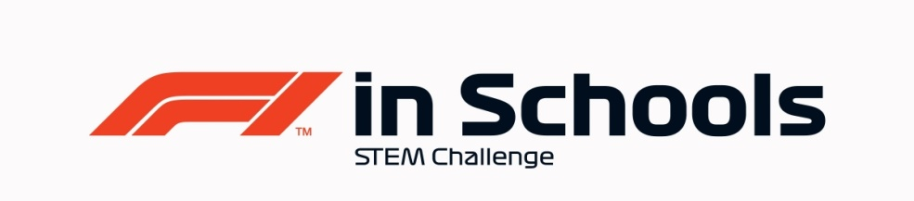
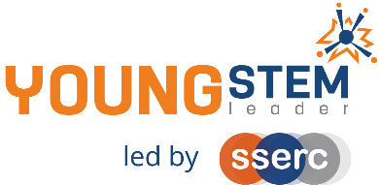
Young STEM Leader & F1 in Schools
Auto-award agreement: Development Class Regional Finalists and YSL4
This document details how participants in the Development Class of F1 in Schools Regional Finals can be presented for the Young STEM Leader Award at SCQF Level 4 (YSL4).
The table below provides guidance on the how the many tasks, activities and learning experiences associated with Development Class of F1 in Schools at Regional Level will provide effective evidence in meeting the learning outcomes of the Young STEM Leader Award at SCQF Level 4. Professional judgement should always be used. Alternative examples/methods of evidence are acceptable provided these meet the associated learning outcome(s).
YSLP Learning Outcome | YSLP Log task | Corresponding F1 in Schools activity | Notes
LO1  Understand the skills and qualities needed for effective, inclusive leadership | 1 | Launch, induction activity, team building, SWOT Analysis and/or other suitable. | Can be done in a general setting such as initial induction to F1 in Schools or other independent learning event.  Can also be covered independent of F1 in Schools as a stand-alone learning activity.
LO2  Be able to improve leadership skills and qualities | 1 | Throughout the competition, taking ownership and leading on each individuals job role. | Can be linked to any relevant self-evaluation exercise or as part of the team building activities and included in the Enterprise portfolio. Also evidenced in record of team meetings.
LO3  Understand how to work as part of a team in their learning community | 2 | Launch day and throughout F1 in Schools | Can be covered in a general setting such as initial induction to F1 in Schools, and team members will continue to develop and improve in this area as they gain more experience throughout the F1 Season.  This can be evidenced in the presentation where teams will explain how they worked together to achieve their goals.
LO4  Understand how STEM activities, events and interactions can be used to demonstrate the impact of STEM | 3 | Looking at alumni of F1 in Schools and identifying the impact of participating in the F1 in Schools competition.  During Research when looking into car design and development, considering Formula E. Identifying impacts of the sport.  Identifying impacts in STEM made by companies that are researched for sponsorship. | Can be covered during the introduction in terms of the impact of F1 in Schools, and throughout the competition at any point research is required. In addition, this could be achieved early in the Season when researching STEM industries for sponsorship.
LO5  Understand the importance of health and safety when leading STEM activities, events or interactions  LO6  Plan STEM activities, events or interactions  LO7  Be able to lead STEM activities, events or interactions (with reasonable assistance, supervision and/or support)  LO8  Be able to evaluate a STEM activity, event or interaction | 4  5 | Any relevant point where Health and Safety is involved: practical workshops, operating CAD/CAM equipment to produce F1 Race Cars and Team Merchandise, company visit, building of pit display, risk assessments, etc.  Also when teams are allowing others to use F1 in Schools equipment for educational/promotional reasons.  The planning and delivery of all practical work and leadership activity required to compete at Regional Finals.  Final presentation to judging panel.  The Design & Engineering and Enterprise Folio will also provide a range of evidence. | Can be done during company visits, workshops, practical learning and of course in participating in the Regional Final event, considering the F1 in Schools Risk Assessment.  Also at events promoting and fundraising for F1 in Schools, where pupils will create or amend a Risk Assessment.  Evidence of this may be found in all submissions for F1 in Schools Regional Final.  Additional leadership activity such as supporting junior teams, working with primaries or leading school assemblies can supplement evidence.
LO1 through 8 | All | All | The entirety of Development Class F1 in Schools Regional Finalists work should be considered to encapsulate all eight LOs of YSLP at SCQF Level 4. Evidence of young people having achieved all eight LOs should be viewed holistically as part of the Regional Finals event, where the Folios, Cars, Social Media and Sponsorships will be submitted as well as the Presentations delivered and Pit Display judged.

F1 in Schools Development Class Regional Finalists
Nomination for Young STEM Leader Award at SCQF Level 4
Declaration
To be completed by the appropriate school staff member.
I/we can confirm that the members of our project team have:
Action | Y/N
F1 in Schools approval for this nomination
Completed the Design & Engineering and Enterprise Folios
Understand how STEM can positively impact themselves, society and the environment
Researched STEM developments in their own country
Promoted STEM/F1 in Schools on social media and/or within their setting
Delivered their final presentation and built their Pit Display
Learned and developed in alignment with and coverage of the eight learning outcomes of YSL4

Staff name:
School:
Number of learners to be certificated:
Year group:
Date:

This completed declaration should be emailed to youngstemleader@sserc.scot who will action the certification process for the learners. Please make the subject of the email “F1 in Schools YSL5 certification request”. You must cc Mark Wemyss-Holden in this email.
Please also attach a sample of the evidence generated during F1 in Schools that satisfies the award agreement as detailed above (e.g. Script or Powerpoint of Verbal Presentation, Enterprise Folio, Design & Engineering Folio, Social Media Plans etc).

